Question1.

Consider the following hierarchy along with suggested data members of classes:

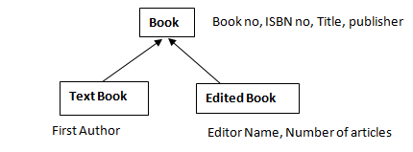

# Design and implement the classes in the hierarchy using C++. You may add more data members in the classes, if needed.

# Include at least one constructor of each class in your Implementation. Also implement a function display-book-info ( ) that displays all the information of related object. Write appropriate main ( ) function such that it, Demonstrates polymorphism while using function display-book-info ( ). [20 Marks]

# Question2.

# Write a Program to Overload Area () function to calculate area of Circle, Rectangle, Square.

# [10 Marks]

Question1.

Consider the following hierarchy along with suggested data members of classes:

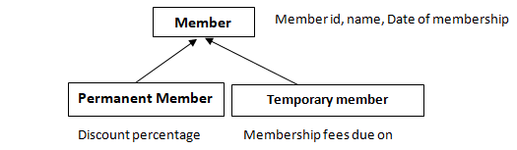

Design and implement the classes in the hierarchy using C++. You may add more data members in the classes, if needed.

You should include at least one constructor in each class. All the classes should have a member function print_member_info ( ) which prints all the data of an object of that class. You must demonstrate polymorphism using print_member_info ( ) and appropriate main ( ) function. **[20 Marks]**

Question2.

Implement a class ‘printData’ with three member function all with the same name

1. Print (int).

2. Print (char *)

3. Print (int []) **(10 Marks)**

Question1.

Define a class name Clock with three integer data members for hours, minutes and seconds. Perform below operations

1. Write no argument and parametrized constructor.

2. Overload below operators

a) Binary (+) operator to add two Clock Objects.

b) Unary (++) pre increment operator to increment values of hours, minutes and seconds.

3. Display () function to display all the data. **[20 Marks]**

Question2.

Write a program to facilitate user to handle any chance of divide by zero exception.

**[10 Marks]**

Question1.

Create a class called employee that contains a name and an employee number. Include a member function called getdata () to get data from the user, another function called putdata () to display the data. Write a main() program to exercise this class. It should create an array of type employee and then invite the user to input data for n employees. **[20 Marks]**

Question2.

Write a C++ program to overload Max () function which will do below tasks.

1. Find max of two numbes.

2. Find max from array **[10 Marks]**

Question1.

Create a class DONOR that contains donor number, donor name, age address, sex and blood group.

Write a Menu driven C++ program to display the number, name and address of the donors for the following categories:

(a) blood donors having the blood group A+

(b) blood donors in the age group between 16 to 30

(c) female donors having blood group A in the age between 20 and 25.  **(10 Marks)**

Using pointers create a class and write a program to get the n names and display them in sorted order. **(5 Marks)**

Question2.

Implement a class „Array to overload following functions as follows: **(15 marks)**

a) intMinimum (int, int) – returns the minimum between the two integer arguments [2]

b) int Minimum (int *a, int arraylength) – returns the minimum integer from an array 'a' [5]

c) Void Minimum (int *a, int arrarylength, int n) – display all elements from the array 'a' which are lesser than given number 'n'.

Question1.

Create a class called Musicians to contain three methods string ( ), wind ( ) and perc ( ).

Each of these methods should initialize a string array to contain the following instruments

- veena, guitar, sitar, sarod and mandolin under string ( )

- flute, clarinet saxophone, nadhaswaram and piccolo under wind ( )

- tabla, mridangam, bangos, drums and tambour under perc ( )

It should also display the contents of the arrays that are initialized**. (5 marks)**

Create a derived class called TypeIns to contain a method called get ( ) and show ( ).

The get ( ) method must display a means as follows:

Type of instruments to be displayed **(10 marks)**

1. String instruments

2. Wind instruments

3.Percussion instruments

Show ( ) method should display the relevant detail according to our choice.

The base class variables must be accessible only to its derived classes**. (5 marks)**

Question2.

Write C++ class Integer which contains (int num) as data member. Display below details.

1. No argument and parameterized constructor.

2. Display how many objects of this class are created. **(10 Marks)**